Deletion in Trie:

## Case 1:

Some other prefix of string is same as the one that we want to delete. (API, APPLE)

For example in this Trie if we want to delete ‘API’ we find another string (“APPLE”) that has common prefix with the API.

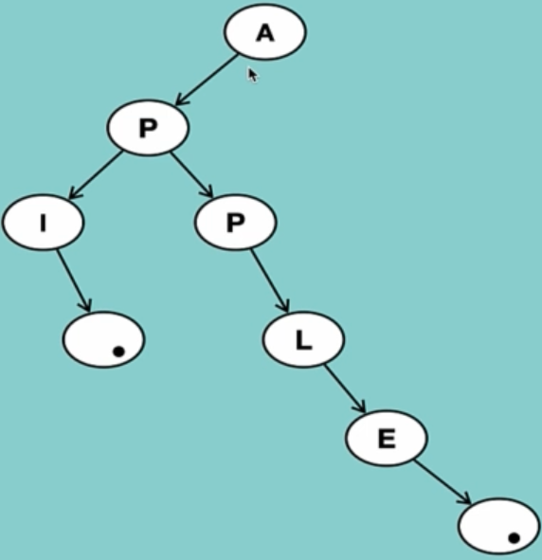

Note: Deletion from string always happen from the leaf Node not from the top.

After checking that a string is located fully in the Trie (in this case API is a complete string because it has an end of String Property on it as True)

If there were not any other node depending on it, we simply delete it.

* We can easily delete the dot node (it doesn’t have any node depending on it)
* After deletion we continue one step up
* One more time after deleting I neither of nodes get impacted from it so we delete it
* One step up and we enrich P
* Now if we delete P we see that another word gets impacted so we stop and API is successfully deleted.

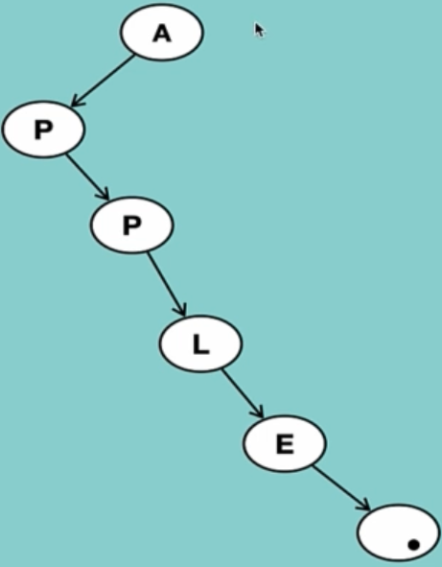

## Case 2:

We want to delete a string which is prefix of another string (API,APIS)

If we want to delete API, APIS will be impact, so we just need to change the property of end of string for the S character to False.

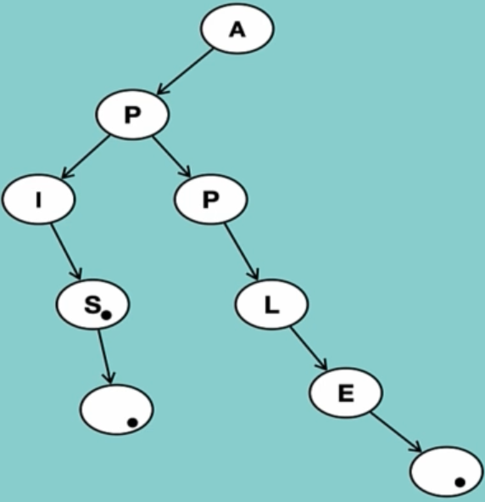

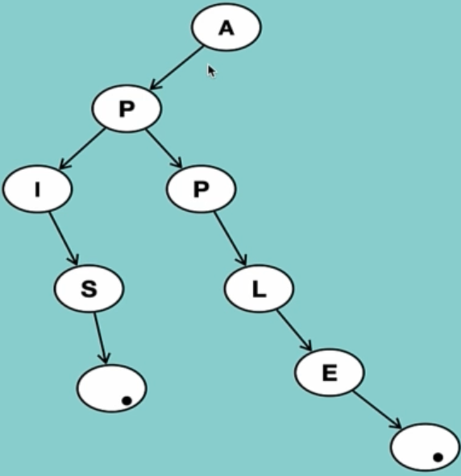

## Case 3:

Other string is a prefix of this string. (APIS, AP)

We start from the root Node and delete until we enrich end of string and set it to false and create a new node and then set the end of string to True.

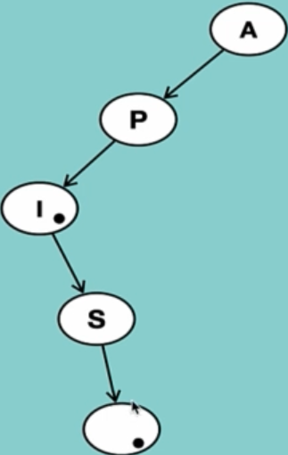

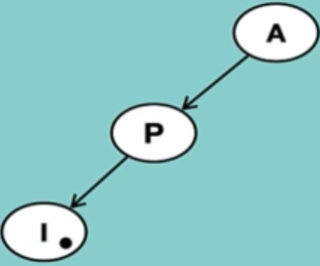

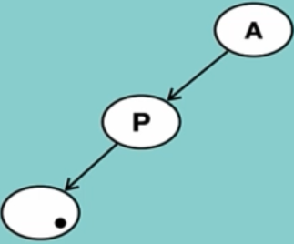

## Case 4:

We don’t have any node depends on it.

We start from the leaf node and check if another string depends on it.

And then simply delete everything from the string.